# Online Application Form: Instruction Guideline

# 

1. Visit the __________ page to apply for the grant.
2. Here, you are required to sign up.

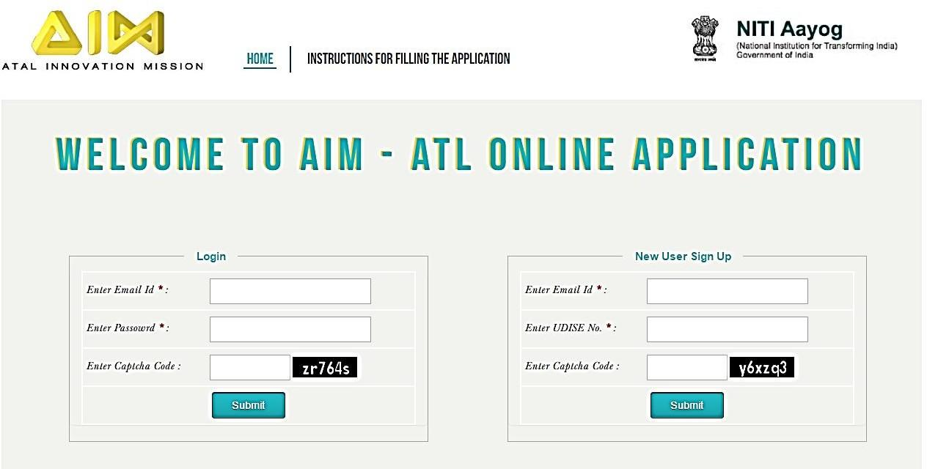

.

1. After successfully signing up, a confirmation mail will be received on your registered email. Please check your spam folders as well for the email.
2. Once confirmation is received, you can now log in using the email address and password.
3. The application form is divided into five sections.
   1. Contact Information
   2. Basic Information
   3. Performance of School
   4. Grant Related Information
   5. Technical Specifications

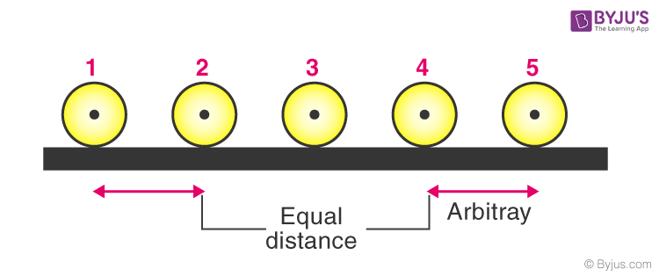



1. Please keep on saving the form as you proceed to the next sections.
2. The first section deals with the contact information related to the school. All the details are mandatory.

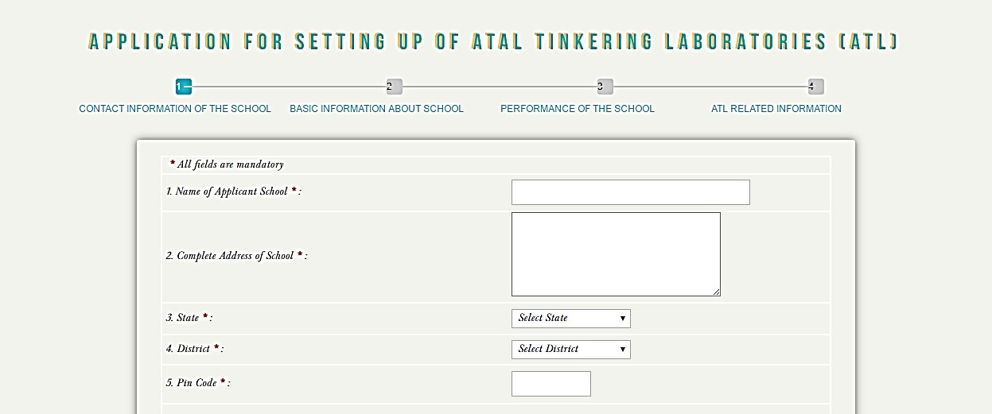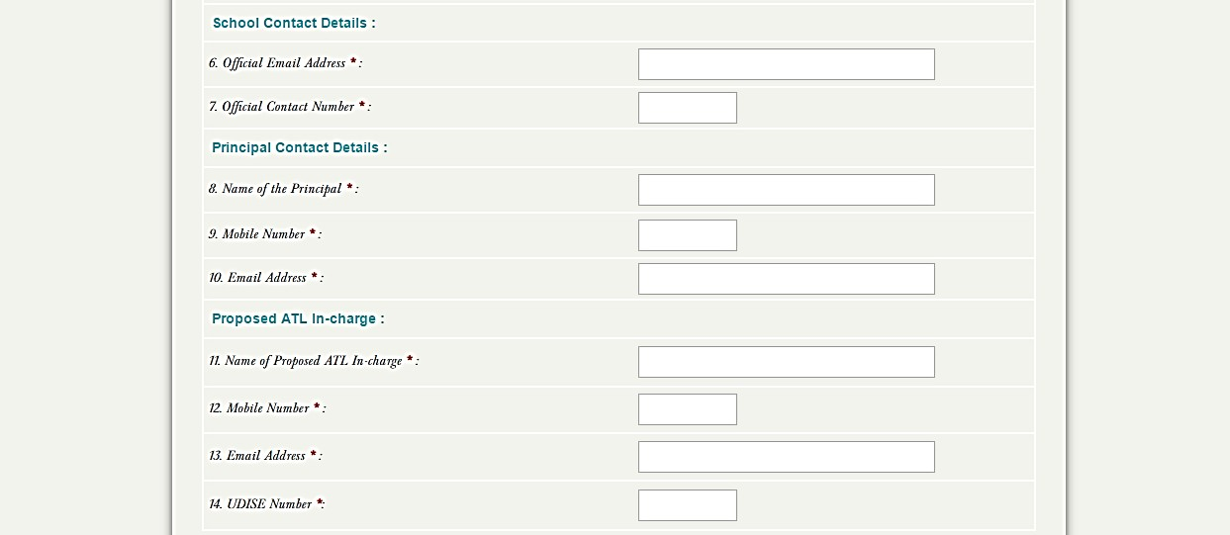

1. Please proceed to the next section after completing the first section. The next section is the basic information about school like year of establishment, board of affiliation, education grade offered in school, total student enrolment, total number of teachers in school etc. All questions in this section are mandatory

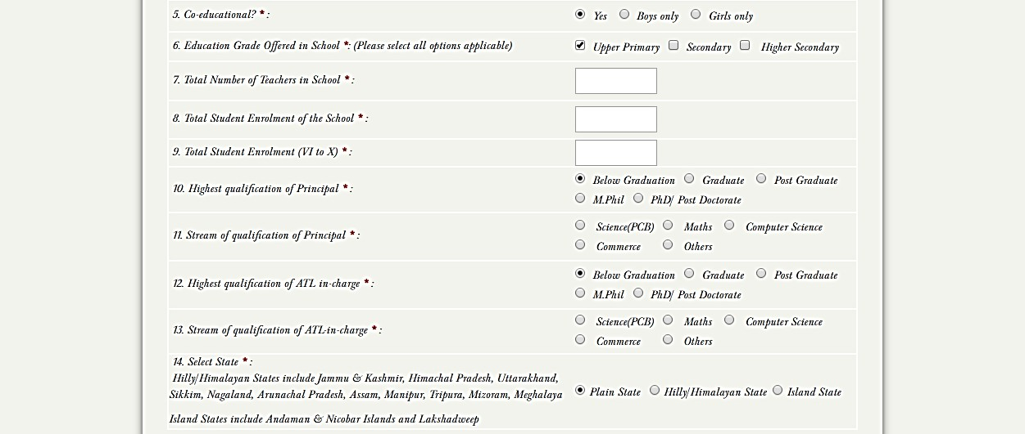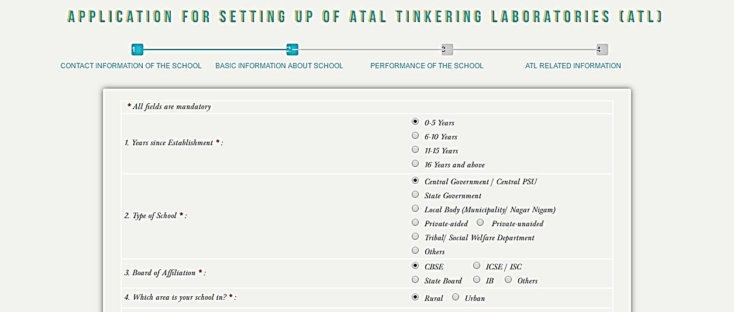

1. The third section includes questions related to the overall performance of the school in various activities.

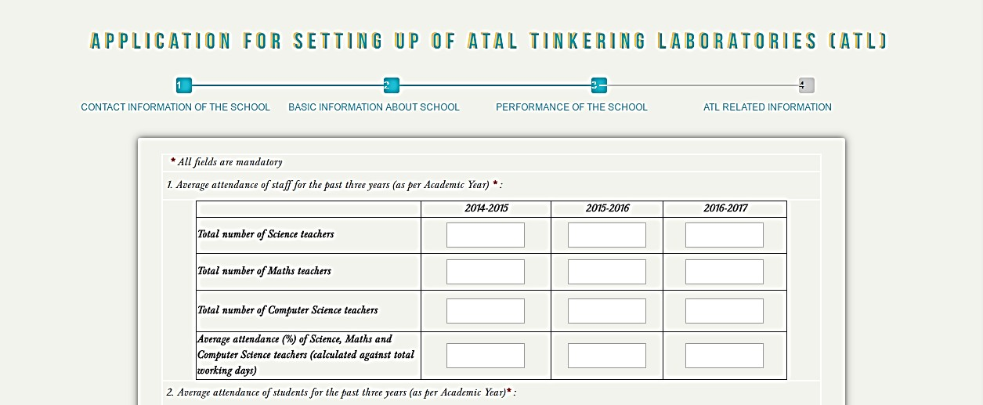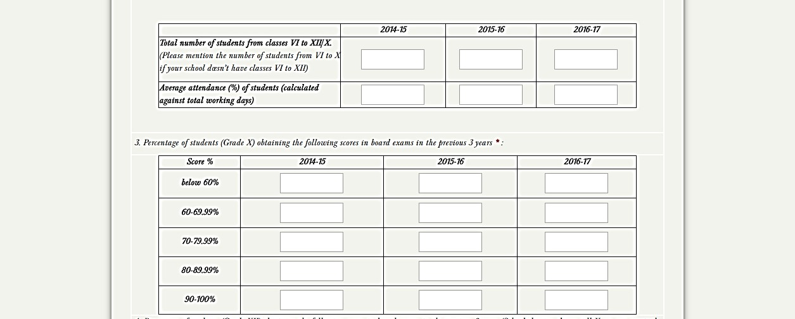

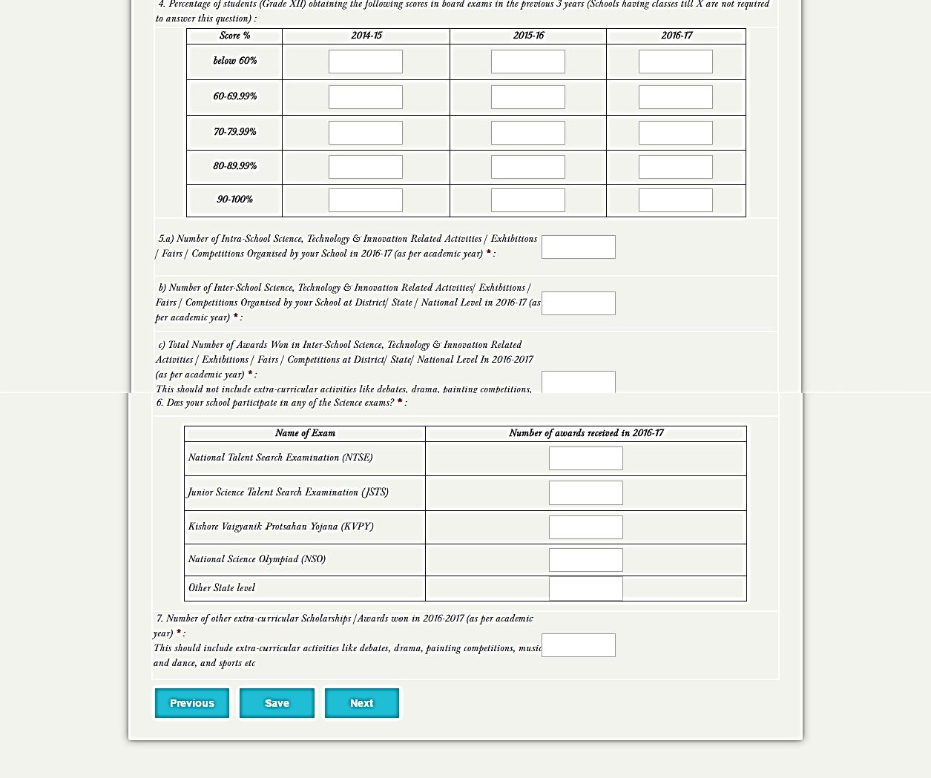

1. The next section will be for the grant related information. You need to select the option for which category you are applying.

* Applying Grant Category 1: STEM Lab
* Applying Grant Category 2: STEM + Computer Lab

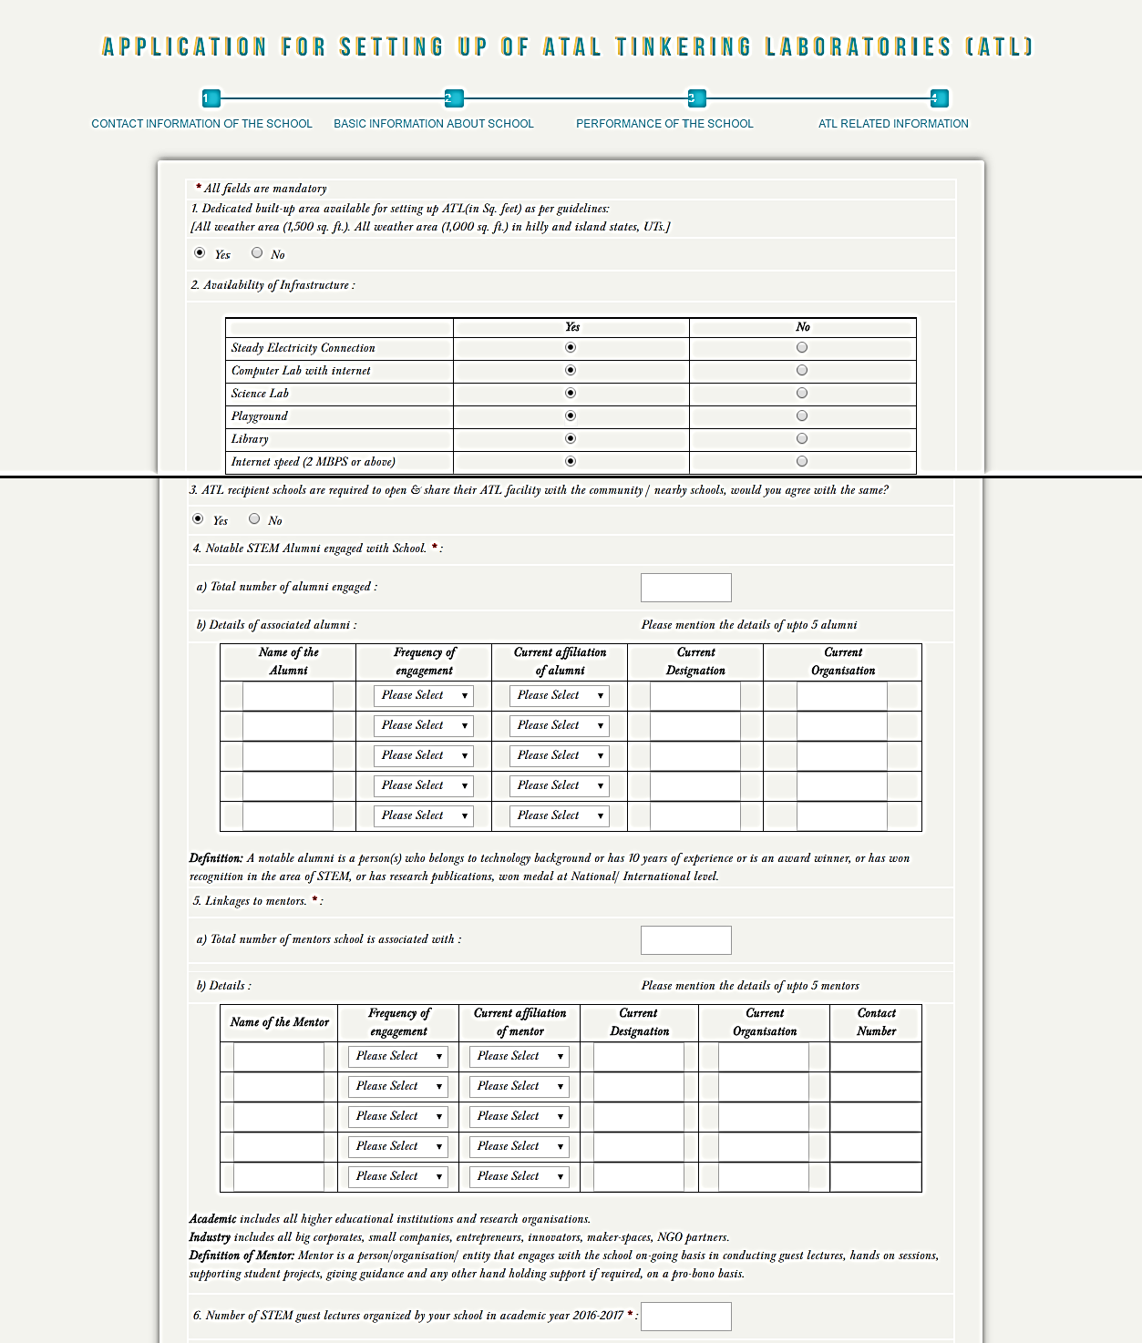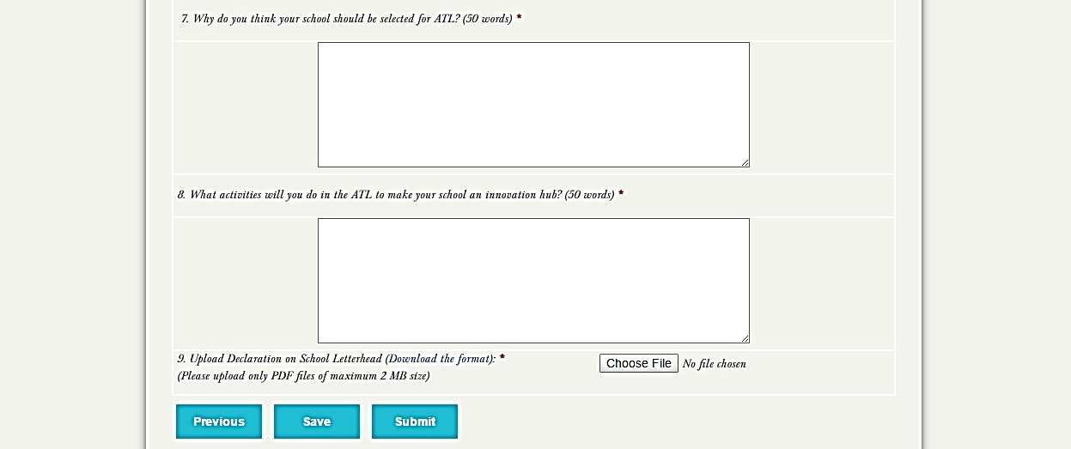

**Note the following**

1. A notable alumi is a person(s) who belongs to a technology background or has 10 years of experience or is an award winner, or has won recognition in the area of STEM, or has research publications, won a medal at the National/ International level. Please keep this definition in mind while filling up the school alumni details. Please mention the details of upto 5 alumni.
2. Mentor is a person/organisation/ entity that engages with the ongoing school basis in conducting guest lectures, and hands-on sessions, supporting student projects, giving guidance and any other hand-holding support, if required, on a pro-bono basis. Please keep this definition in mind while filling up the details of the mentors associated with the school. Please mention the details of up to 5 mentors.
3. The final section is for the technical specifications. Here you have to fill in all the details related to the lab. For those who are applying for the STEM lab + Computer Lab need to fill as per Section 5.

**Section -1 [Electronics/Embedded]**

| **Technical Specification - STEM Lab** | | | | |
| --- | --- | --- | --- | --- |
| **S. No.** | **Category** | **Name** | **Specification** |  |
| | 1 | | --- | | **Electronics/Embedded** | Arduino Uno or equivalent | ATmega328P - 8-bit AVR family microcontroller, equivalent or better. Operat ing Voltage : 5v Digital 1/0 Pins: 14 {of which 6 provide PWM output), PWM Digital 1/0 Pins: 6 Accessories: compatible USB cable {length - 6 inch or more) |  |
| 2 | Arduino Nano or equivalent | ATmega328P - 8-bit AVR family microcontroller, equivalent or better. Operating Voltage : 5V , Digital 1/0 Pins : 14 {of which 6 provide PWM output), Analog Input Pins: 8 Accessories: Compatible USB cable { length -6 inch or more) |  |
| 3 | Arduino Mega or equivalent | ATmega 2560P - 8-bit AVR family microcontroller, equivalent or better. Operating Voltage: 5V , Digital 1/0 Pins : 54 (of which 6 provide PWM output), Analog Input Pins: 16. Accessories: Compatible USB cable ( length -6 inch or more) |  |
| 4 | Raspberry Pi | RASPBERRY Pl PICO, MicroSD card - 32 GB, USB 3.0 cable (1 meter) |  |
| 5 | Breadboards & Mini Breadboard | Solderless 400 pin breadboard |  |
| 6 | Breadboards & Mini Breadboard | Solderless 800 pin breadboard |  |
| 7 | Breadboards & Mini Breadboard | Self-Adhesive Proto Shield |  |
| 8 | General Purpose solderable Board | FR2 A Grade Material (140 x 90 mm) |  |
| 9 | General Purpose solderable Board | FR2 A Grade Material (80 x 55 mm) |  |
| 10 | Berg Strips | Female Berg St rip , 2.54mm pitch, 40 pin single ro w, breakable pin |  |
| 11 | Berg Strips | Male Berg Strip , 2.54mm pitch, 40 pin single row, breakable pin |  |
| 12 | 16x2 LCD display | Dot matrix LCD display. 16 characters X 2 lines. 12C |  |
| 13 | USB Cables | USB Cable Set (A to B, 12 inch or more) |  |
| 14 | USB Cables | USB Cable Set (Mini, 12 inches or more) |  |
| 15 | Battery | 9V battery with various colour equivalent or better |  |
| 16 | Resistor Kit | One kit contains - 30 carbon film resistors of 20 different resistance values each assorted, packaged together and labelled . Wattage: 0.125W to 1W , Values : 0Ω , 1.5Ω , 4.7Ω , 10Ω , 47Ω , 100Ω , 220Ω , 330Ω , 470Ω , 680Ω, lkΩ, 2.2kΩ , 3.3kΩ , 4.7kΩ , lOkΩ, 22kΩ, 47kΩ, lOOkΩ, 330kΩ, lMΩ |  |
| 17 | Capacitor Kit | One kit contains - 20 electrolytic capacitors of 10 different capacitance values each. Assorted kit packaged together and labelled.Values: lOpF, 22pF, lOOpF, lnF, lOnF, l OOnF, lµF, lOµF, l OOµF, lOOOµF |  |
| 18 | Linear Voltage Regulator | 7805, 7812,7809 |  |
| 19 | Water Pump module | DC12V 3W Submersible Water Pump |  |
| 20 | Piezoelectric Plate | Normal Copper based 4 cm Diameter approx . |  |
| 21 | 8*8 LED Matrix Module | Max7219 Dot LED Matrix Module. MCU Control LED Display Module |  |
| 22 | Bluetooth module | HC 05 Bluetooth module, Voltage Rating: 5 V |  |
| 23 | 7 Segment Led Display | LED 4-Digit Display Module, Voltage Rating: 2.4V to 5.5V. 4-Pin interface:Vee, Gnd, Data, Clock |  |
| 24 | GSM | Sim900 GPRS Transfer Board Micro Sim Gsm Core TTL Port Module for Arduino |  |
| 25 | GPS | GY-NE06MV2 new GPS modu le |  |
| 26 | Laser Diode Emitter | 650 nm 5mW Mini Laser Dot Diode Module |  |
| 27 | LDR Module | 5mm/12mm, Photosensitive LOR Light Sensor Module |  |
| 28 | Keypad | Universal 16 Key Switch Keypad |  |
| 29 | Joystick | 2-axis joystick with push button function |  |
| 30 | Active Buzzer | Small 5 volt |  |
| 31 | Active Buzzer | Big 5 volt |  |
| 32 | Motor driver Module | L293D |  |
| 33 | Sound Playback Module | ISD1820 voice record ing module or equivalent |  |
| 34 | DC Plastic Gear motor with wheel | 12V, 150RPM, Side Shaft BO (Battery operation) Motor |  |
| 35 | Node MCU | ESP 8266 12C, 1 wire, plug and play |  |
| 36 | WeMos D1 R2 | WeMos D1 R2 with WiFi ESP 8266, Operating Volt age: 5V |  |
| 37 | Vibrating Motor | Weight: 10 Grams, Operating Voltage: 1.5 to 3V |  |
| 38 | Alligator Connectors | Multi-Colour Alligator Connectors - 12 inch |  |
| 39 | Battery clips with DC Jack | 9-volt battery clips with DC Jack |  |
| 40 | Hook-up Wires | Red & Black set 100 Meters each |  |
| 41 | Jumper Cable | Male-Male |  |
| 42 | Jumper Cable | Male-Female |  |
| 43 | Jumper Cable | Female-Female |  |
| 44 | RGB LEDs | Regular 5mm 3-5 volt Range |  |
| 45 | LEDs (Red) | Regular 5mm 3-5 volt Range |  |
| 46 | LEDs (Green) | Regular 5mm 3-5 volt Range |  |
| 47 | LEDs (Blue) | Regular 5mm 3-5 volt Range |  |
| 48 | LEDs (Yellow) | Regular 5mm 3-5 volt Range |  |
| 49 | LEDs (White) | Regular 5mm 3-5 volt Range |  |
| 50 | Timer IC- LM 555 | LM 555 Timer IC. Voltage range - 4.5V to 16V |  |
| 51 | Atmega16u2 | 8-bit microcontroller Individual IC (DIP).Voltage range: 2.7V to 5.5V. Operational Range: -40°C to +80°c |  |
| 52 | Diodes and Transistors Kit | One Kit Contains - 25 Assorted Basic Diodes of 4 different types each.Types: NPN Transistor - 2N3904, BC547 PNP Transistor - 2N3906, BC557 Silicon Diode - 1N4148, Power Diode - 1N4004/4001.Equivalent or better.Wattage: lW, Current rating: lA. Assorted kit packaged together and labelled. |  |
| 53 | Button Switch Set | One Kit Contains - 100 buttons of different types. Types: Push, toggle, rotary, selector and slide switch. Assorted kit packaged together and labelled. |  |
| 54 | Capacitative touch Module | MPR 121 with I2C. Voltage Range:2.5V to 3.6V DC. |  |
| 55 | Capacitative Touch Switch Module | Digital Capacitive touch switch module -TTP223B Voltage Range: 2V to 5V DC. |  |
| 56 | IR Sensors, Obstacle avoider sensor module | LM393 Detection distance:2 - 30 cm, Detection angle: 30 - 40° |  |
| 57 | Triple Axis Magnetometer | 3-Axis Magneto resistive Sensors I2C Digital Interface Integrated 12-bit ADC Range of -8 to +8 Gauss 160 Hz Maximum o/p rate |  |
| 58 | Humidity Sensor | Operating range:20-95 % RH Temperature: 0 - 60 Celsius Power supply:1.5V AC (Max sine) Operating frequency:500Hz - 2kHz |  |
| 59 | M Q Series | MQ - 2 Smoke Detection |  |
| 60 | M Q Series | MQ-3 Alcohol - Ethanol Sensor |  |
| 61 | M Q Series | M Q-4 Methane Natural Gas Sensor |  |
| 62 | M Q Series | MQ-5 Methane Liquified Gas Sensor |  |
| 63 | M Q Series | MQ-6 Liquified Petroleum Gas Sensor |  |
| 64 | M Q Series | MQ-7 High Sensitivity CO Carbon Monoxide Sensor Detector |  |
| 65 | M Q Series | MQ-8 Hydrogen Gas Sensor |  |
| 66 | M Q Series | MQ-135 Air Quality Sensor |  |
| 67 | IR transmitter/receiver | TSOP 1738 Switching rate: 38 KHz Voltage Rating: 5V |  |
| 68 | Ultrasonic Sensor Module HC-SR-04 or compatible | Working Voltage - DC 5V Working current - 15 mA Working Frequency - 40 Hz Range - 1 cm to 4 m Effectual Angle - <15° M easuring Angle - 30° Resolution - 0.3 cm |  |
| 69 | Triple Axis accelerometer- | 3-axis sensing Small, low profile package 4 mm x 4 mm x 1.45 mm LFCSP Low Powe r: 350 µA (typical)Single- supp ly operation: 1.8 V to 3.6 V Temperature stability |  |
| 70 | PIR Motion Detector Module | High digital pulse when motion detected Low digital pulse when idle /no motion detected Sensitivity range (up to 6 m), Power supp ly: SV - 12V |  |
| 71 | Pulse Rate Heart Sensor | Pulse Rate Sen sor Finger Based (finger or earlobe) Workin g voltage 3-SV |  |
| 72 | Relay Module | 5V 10A - 2 Channe l Relay Module. Compatible with Arduino |  |
| 73 | Relay Module | 5V 10A - 1 Channel Relay Module. Compatible with Arduino |  |
| 74 | Big Sound microphone module | Large Electret capsule sound module |  |
| 75 | Big Sound microphone mod ule | Large Electret capsule sound module |  |
| 76 | Soil Moisture Sensor module | FC-28 with LM293 comparat or Operating Voltage: 3.3V to SV. |  |
| 77 | Touch Sensor | Capacitive Touch Sensor Module. TTP22X series. Voltage Range: 2.4V to 5.SV |  |
| 78 | Metal Touch Sensor Module | KY-036 or equivalent metal touch sensor module |  |
| 79 | Rain Drop Sensor | Rain Sensitive, Rain Drop Detection Sensor Module. Voltage Range: 3.3V to 5. SV. Size: 5m m X 40mm or equivalent |  |
| 80 | Flex Sensor | Flex Sensor. Size - 2.2 Inches |  |
| 81 | Temperature Sensor | LM35 Fu ll range temperature sensor. Voltage Range: 4V to 30V. Error: ±0.5°C |  |
| 82 | Temperature and humidity sensor module | DHT 11 Voltage Range: 3V to SV |  |
| 83 | Force Pressure Sensor | Force sensitive resistor with a square, l.75xl.5" sensing area |  |
| 84 | Colour Recognit ion Sensor | TCS3200 Colour Re cognit ion Sensor |  |
| 85 | Water Flow Sensor | Arduino Compatible Water flow sensor. 5V DC In put. |  |
| 86 | Sound Sensor | Sound Sensor Module, Microphones modu le |  |
| 87 | IR Sensors Array module for Line Following | 8 IR Sensors Array module for Line Following Operating Voltage: 5V |  |
| 88 | Power Bank | 10000 mAh 5-volt Power Bank |  |
| 89 | RFID Reader - Tags | Current :13-26mA / DC 3.3V Idle Current :10-13mA Sleep Current<80uA Peak Current<30mA Operating Fr equency: 13.56MHz<30mA Read range between 20 cm to lm |  |
| 90 | RF Modules Tx & Rx 315 MHz ASK | Frequency Range: 433.92/315 MHz Supply Voltage: 3 - 6 V Output : 4 - 16 Dbm Low power consumption Easy application |  |
| 91 | Stepper motor with Driver board | 28BYJ-48 ULN2003 5V Stepper Motor+ ULN2003 Driver Board |  |

**Section -2 [Rapid Prototyping]**

| | **Rapid Prototyping Tools** | | --- | | | | | |
| --- | --- | --- | --- | --- | --- |
| **S. No.** | **Category** | **Name** | **Description** | **Quantity** |
| 1 | Rapid Prototyping Tools | 3D Printer Kit and tools | Printer Type: FDM (Fused Deposition M odelling), Minimum Dimensions: 220mm *220mm *220mmBuild Size or 4 litre Build Volum e., Nozzle: 0.3mm to 0.4mm nozzle diameter, slici ng software should be free or Open sou rce, LCD Screen UI that display print metrics, Heated Print bed. Material Compatibility - PLA, ABS, and derivatives of PLA, Nin jafl ex Quality Anti-bacterial/ fungal Cover. Repair Kit - with spare springs, screws, keys, tweezers, etc. |  |
| 2 | Dedicated UPS/Power back up | Dedicated UPS/Power Back up with 2-hour battery backup. |  |
| 3 | Filament for 3D printer | Compatible 1000 Grams Filament in 5 different colours |  |
| 4 | Filament Storage Box | Compatible Filament storage box |  |

**Section -3 [Robotics]**

| **Category** | **Name** | **Description** |
| --- | --- | --- |
| Robotics | Qooper | Metallic Body |
| Sensor Set | Light Sensor, PIR Motion Sensor, Sound Sensor, Ultrasonic Sensor, Temperature Humidity Sensors, Line Follower Sensor, Color Sensor, Gyroscope Sensor, |
| AA Rechargable Battery with Charger | Battery- AA 1300mAh, Charger- SUPPORTS INPUT: 220V AC, 50Hz , SUPPORTS OUTPUT: AA/AAA 2.4V DC 240mA , |

**Section -4 [Drone]**

| **S. No.** | **Category** | **Name** | **Description** |
| --- | --- | --- | --- |
| 1 | Drone | Pluto X | PlutoX Drone {16 GPIOs 2 DAC Channels 10 DOF Sensor Suit 4 Mosfet Drivers 2 UARTS 20 Pin Header 4 H Bridge Drivers 11 Timer Channels Flight Time 9 mins Payload 15g SDK API Based interface Communication WiFi (60m)} X-Breakout to further experiments Smartphone App Cygnus IDE Proptool, Propeller set and 2 motors Camera Module |
| 2 | Charging cable and Adaptor | Adaptor:- Output 5v and 2 AMP, micro USB type cable |

**Section -5 [Smart Computer Tool]**

| **Category** | **Name** | **Specification** |
| --- | --- | --- |
| Smart Class & E-Content | MSS | MSS model MSS1C410  Platform Version v 1.0  Processor Intel  Memory 4 GB DDR3  Storage 1 TB SATA  Connectivity 1 Gb Ethernet, Integrated Wireless, Bluetooth 4.2 or higher Powers up to 70 disk-less PCs simultaneously Legacy systems can be used as clients (minimum – Core 2 Duo, 2 GB RAM, Fast Ethernet, no HDD) |
| Smart Class & E-Content | Wacom Tablet | ATmega328P - 8 bit AVR family microcontroller , equivalent or better. Operating Voltage : 5V , Digital 1/0 Pins : 14 {of which 6 provide PWM output), Analog Input Pins : 8 , Accessories : Compatible USB cable { length -6 inch or more) |
| Switch Box |  |  |
| LAN Cat 6 cable |  |  |
| Projector |  |  |

1. Please download the declaration form. Please take a print of the form on the School Letterhead, sign it and upload the scanned version (PDF only).
2. Please read all the questions carefully before submitting. Please note that no edits will not be allowed after the final submission of the form.
3. You can view and print the form after the final submission.
4. You can email us at [___________](mailto:md-aim@gov.in) for any queries. We will respond as soon as possible.

# All the Best!